Cloud Computing

**Name:** Jerusha Angel K

**Register No**: 727721EUCS049

Day-2

**Day 2_EC2_CE1**

**Content Description:**

Create a Windows EC2 instance with t2.micro Instance and show the remote connection of that EC2 Instance.

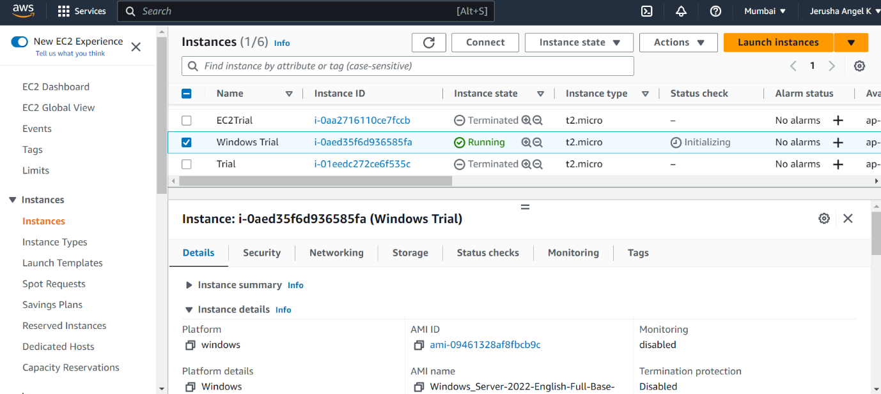

**Day 2_EC2_CE2**

**Content Description:**

Create an EBS volume of 5 GB and attach to a windows EC2 instance and make partition of that EBS volume.

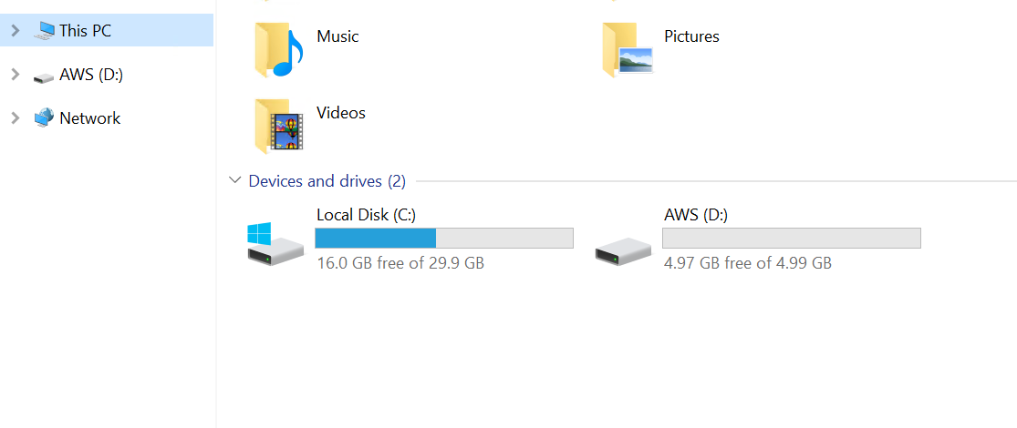

**Day 2_EC2_CE3**

**Content Description:**

Create some files and folders into 5 GB EBS volume of the previous exercise and take a snapshot of that EBS volume.

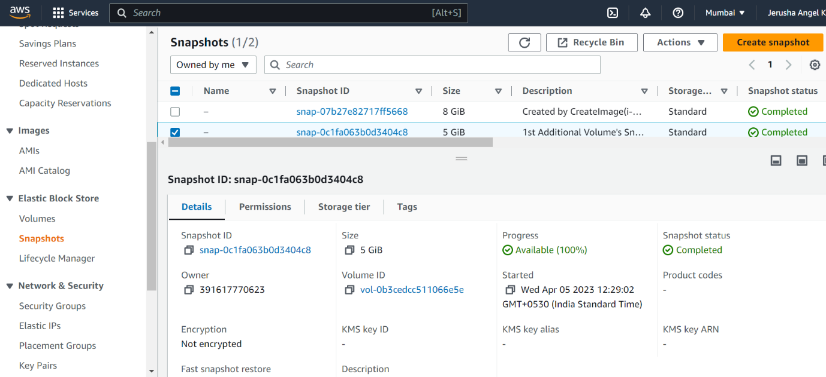

**Day 2_EC2_CE4**

**Content Description:**

Create a Linux EC2 instance with t2.micro Instance and show the remote connection of that EC2 Instance.

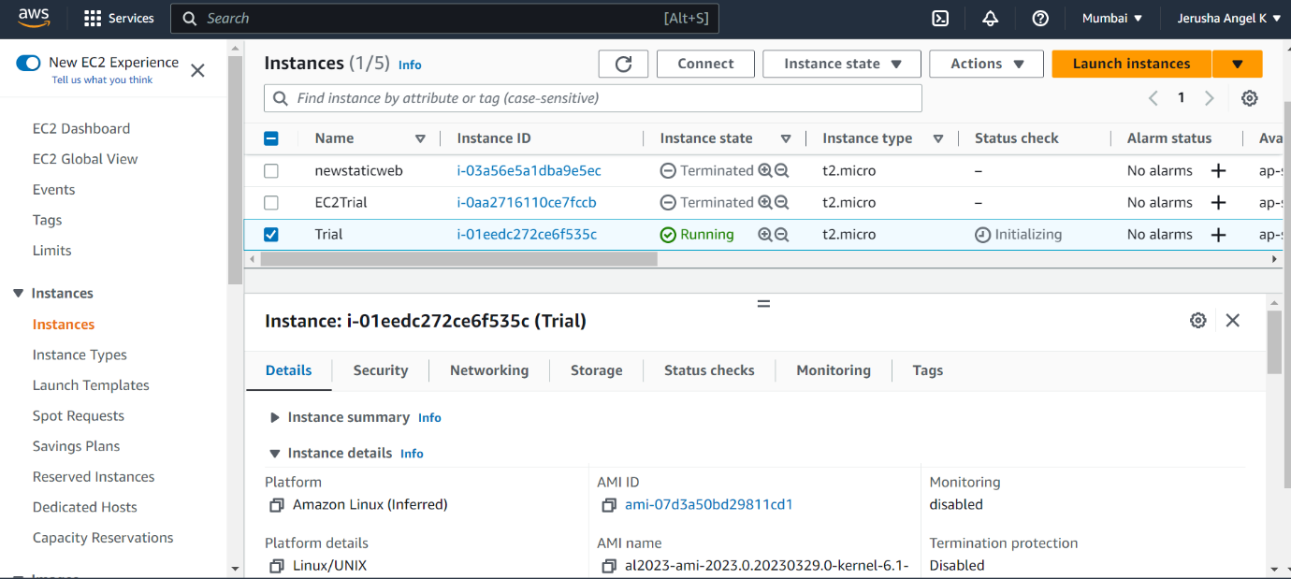

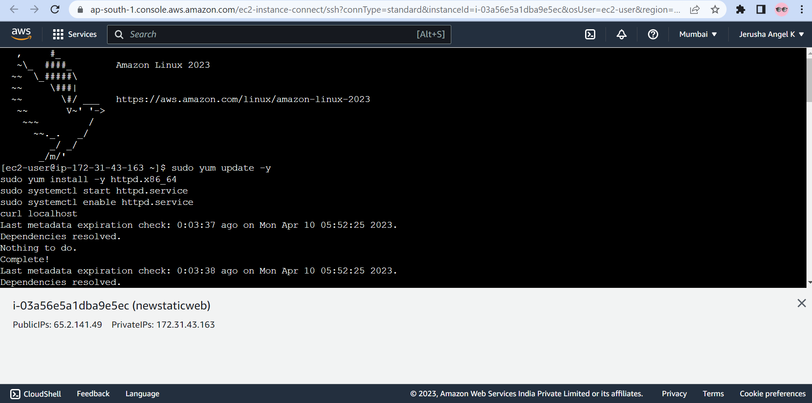

**Day 2_EC2_CE5**

**Content Description:**

Install, Start and Enable the httpd webservice in that Linux EC2 Instance, then host a static website in EC2.

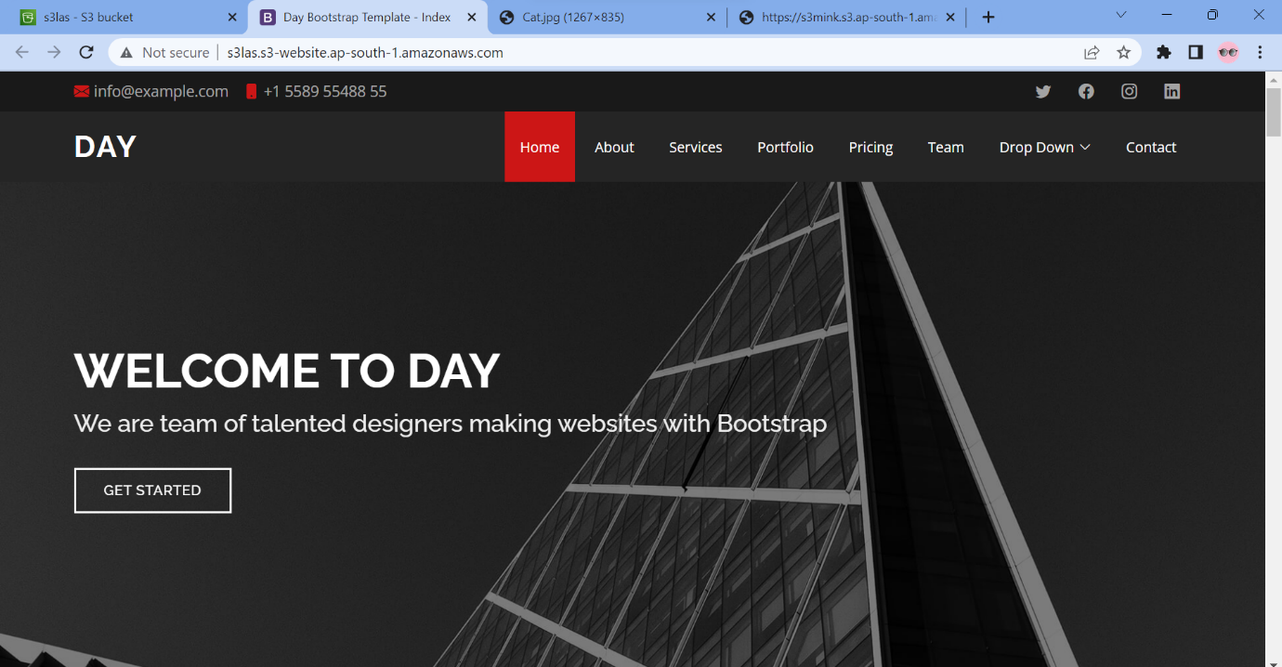

**Day 2_EC2_CE6**

**Content Description:**

Create Image(MyAMI) of the linux Webserver(from the previous exercise) and launch new EC2 instance from the created Image(MyAMI)

